Observation Sheet: The Nernst Equation and Its Applications
Assessment
Experiments S & T
Report ______ /10
Quiz (Online) ______ /10
Total ______ /20
Note: Record all cell potentials to 3 decimal places.

Part I: Effect of Concentration on Electrode Potentials
 | [Ag⁺] (mol/L) | E_{cell} (V) | Cathode
1 | 1.00 × 10⁻⁴ | 0.234 | Ag(s) in 1.00 mol/L sol’n
2 | 1.00 × 10⁻³ | 0.173 | Ag(s) in 1.00 mol/L sol’n
3 | 1.00 × 10⁻² | 0.119 | Ag(s) in 1.00 mol/L sol’n
4 | 1.00 × 10⁻¹ | 0.058 | Ag(s) in 1.00 mol/L sol’n
5 | 1.00 | 0.000 (assumed) | Ag(s) in 1.00 mol/L sol’n

Part II: Determination of an Equilibrium Constant
 | [Ag⁺] (mol/L) | [Cu²⁺] (mol/L) | E_{cell} (V) | Cathode
1 | 1.00 × 10⁻⁴ | 1.00 | 0.253 | Ag(s) in 1.00 x 10^-4mol/L sol’n
2 | 1.00 × 10⁻³ | 1.00 | 0.324 | Ag(s) in 1.00 x 10^-4mol/L sol’n
3 | 1.00 × 10⁻² | 1.00 | 0.352 | Ag(s) in 1.00 x 10^-4mol/L sol’n
4 | 1.00 × 10⁻¹ | 1.00 | 0.400 | Ag(s) in 1.00 x 10^-4mol/L sol’n
5 | 1.00 | 1.00 | 0.044 | Ag(s) in 1.00 x 10^-4mol/L sol’n

Part III: Determination of a Solubility Product (K_{sp})
[Na₂CO₃]: ___1.00 mol/L___ volume of Na₂CO₃ used: __4.00mL_______________
[AgNO₃]: _0.100 mol/L______ volume of AgNO₃ used: __1.00 mL_______________
E_{cell}: ___0.266V______________ Cathode:__Ag(s) in 1.00 mol/L sol’n_______________
Student: (name)___________________________ (signature)______________________________________________

Instructor: (signature)____________________ Bench # ______ Laboratory Section: ______

Report: Experiment S (Voltaic Cells) &
Assessment
Experiments S & T
Report ______ /10
Quiz (Online) ______ /10
Total ______ /20

Experiment T (The Nernst Equation)

Name: ____________________________ Bench #______
Section: ___________ Date: ________________________
Laboratory Instructor: __________________________

Exp. S: Voltaic Cells
The material from Experiment S will be primarily assessed by means of an online quiz administered at the start of Experiment U.

Exp. T Part I: Effect of Concentration on Electrode Potentials
- Complete the following Table: (0.4)

 | [Ag⁺] (mol/L) | Q_{cell} | log Q_{cell} | Measured potential (V)
1 | 1.00 × 10⁻⁴ | 1.00×108 | 8 | 0.234
2 | 1.00 × 10⁻³ | 1.00×106 | 6 | 0.173
3 | 1.00 × 10⁻² | 1.00×104 | 4 | 0.119
4 | 1.00 × 10⁻¹ | 1.00×102 | 2 | 0.058
5 | 1.00 | 1.00 | 0 | 0.00

- Based on your results from the measured cell potentials in the above Table, prepare a graph of E_{cell} versus log Q_{cell} for Part I. You should use spreadsheet software and attach a hardcopy of the graph with this report. The graph should include a calculated best-fit line. (1.0)

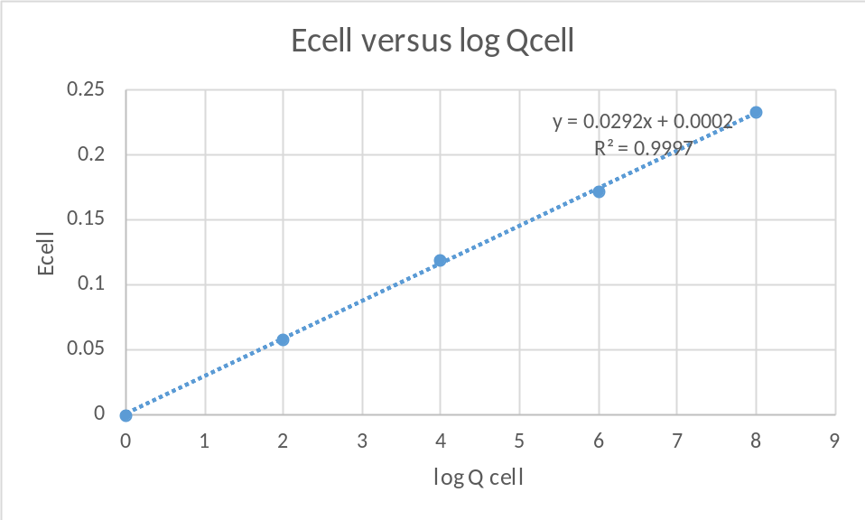

  - What is the slope of the best fit line for the graph, including units? (0.2)

The equation of the best fit line is $y=0.0292x+0.$0002

The slope of the best fit line=0.0292

  - What is the value of the y-intercept of the best-fit line for the graph, including units?
(0.2)
y-intercept$=0.$0002v

- In the previous question, you reported the measured (experimental) value for the slope and y-intercept of the best-fit line.

  - Theoretically, based on the Nernst equation, what should be the value of the slope of this best-fit line. Explain your answer. (0.4)

Experimental value of the slope is -0.0592n. This is from the Nernst equation
Ecell=E0cell-0.0592nlogQ
Comparing with the equation of a line,$y=mx+c$
y=Ecell
m=-0.0592n
$x=logQ_{cell}$
$c=$E0cell
This implies that the slope =$-\frac{0.0592}{n}=0.0292$ at equilibrium
Keq =-0.0592n at equilibrium
$Experimental value of -\frac{0.0592}{n}=0.0292$

  - Theoretically, based on the Nernst equation, what should be the value of the y-intercept of this best-fit line. Explain your answer. (0.4)

The experimental value of y-intercept=E0cell=0.0002v

Exp. T Part II: Determination of an Equilibrium Constant:
2 Ag⁺(aq) + Cu(s) ⇌ Cu²⁺(aq) + 2 Ag(s)
- Complete the following Table: (0.4)
 | [Ag⁺] (mol/L) | Q_{cell} | log Q_{cell} | Measured potential (V)
1 | 1.00 × 10⁻⁴ | 100,000,000 | 8 | 0.253
2 | 1.00 × 10⁻³ | 1,000,000 | 6 | 0.324
3 | 1.00 × 10⁻² | 10,000 | 4 | 0.352
4 | 1.00 × 10⁻¹ | 100 | 2 | 0.400
5 | 1.00 | 0 | 0 | 0.044

- The equilibrium constant for the reaction: 2 Ag⁺(aq) + Cu(s) ⇌ Cu²⁺(aq) + 2 Ag(s)
can be found experimentally by finding the E_{cell} values for a series of cells in which the [Cu²⁺] is kept constant and the concentration of Ag⁺(aq) varies. By plotting a graph of E_{cell} versus log Q_{cell}, the value of Q_{cell} when E_{cell} = 0.000 V can be determined from the x-axis intercept. When E_{cell} = 0.000 V then the system is at equilibrium and Q_{cell} equals K_{eq}.
Prepare a graph of E_{cell} versus log Q_{cell} for Exp T. You should use spreadsheet software and attach a hardcopy of the graph with this report. The graph should include a calculated best-fit line. (1.0)
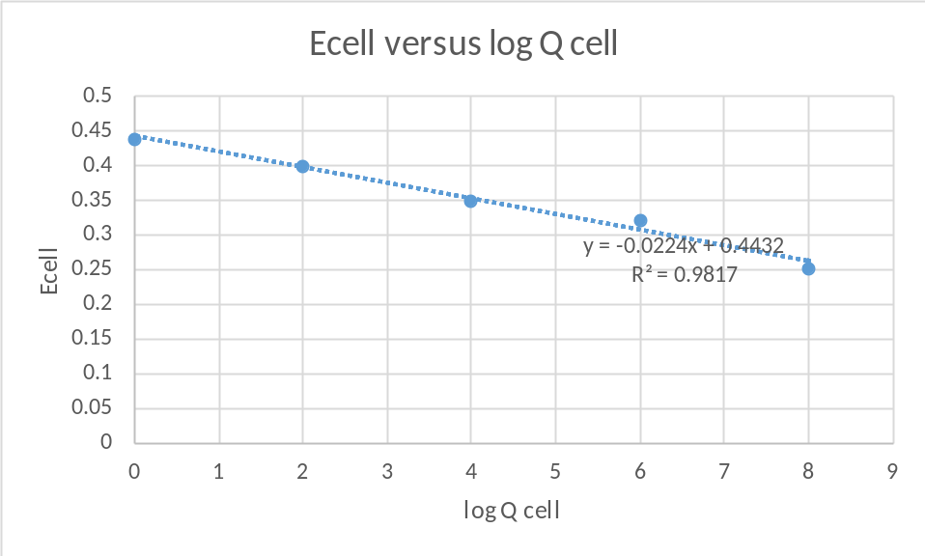

  - What is the slope of the best fit line for the graph, including units? (0.2)

The equation of the best fit line is $y=-0.0224x$+0.4432
the slope of the best fit line=-0.0224v

  - What is the value of the y-intercept of the best-fit line for the graph, including units? (0.2)

y-intercept of the best-fit line=0.4432v

  - Using the linear equation for the best-fit line, calculate the value of the x-intercept, which is the value of x when y = 0. (0.5)
$y=-0.0224x+0.4432$
But $y=0$,
0=-0.0224x+0.4432
0.0224x=0.4432
$x=\frac{0.4432}{0.0224}=19.$79v

  - What is the experimental value for log Q_{cell} when E_{cell} = 0.000V? Hint: consider your answer from part c. (above) and how it relates to the Nernst equation. What is the experimental value of K_{eq} for this reaction? (0.5)
The experimental value of the x-intercept=$logQ_{cell}$.This is from the Nernst equation

Ecell=E0cell-0.0592nlogQ
Comparing with the equation of a line,$y=mx+c$
$y=E_{cell}$
$m=-\frac{0.0592}{n}$
$x=logQ_{cell}$
$c={E^{0}}_{cell}$
This implies that the x-intercept ($logQ_{cell})=19.79$
Keq = Qcell at equilibrium
Keq = antilog(19.79)
$K_{eq}=1.29645$
$E$xperimental value of logQcell=19.79
Experimental value of Keq=1.29645

  - Calculate the theoretical K_{eq} for the above reaction by using the appropriate standard reduction potentials from the Chemistry Data Sheet. (Note: At equilibrium, E_{cell} = 0.000 V.) (0.5)

Ecell=E0cell-0.0592nlogQ
$E_{cell}=0,$ andE0cell=0.462v
E0cell=0.05921logQ
$0.462=0.0592logQ$
logQ=0.4620.0592
Keq=antilog0.4620.0592=0.89232

- A student performed a similar experiment using Au(s) instead of Ag(s) and Au⁺ instead of Ag⁺. If the student were to prepare a plot of E_{cell} versus log Q_{cell} for his/her experimental data, what should be the values of the slope and y-intercept for the best-fit line? (0.8)

If the students uses ${Au}^{+}$ instead of Ag+ the only thing that changes is ${E^{0}}_{cell}$
$E_{cell}={E^{0}}_{cell}-\frac{0.0592}{n}logQ$
${E^{0}}_{cell}=2.$02v

Ecell=2.02-0.0592logQ
Slope=-0.0592
y-intercept=2.02

Part III: Determination of a Solubility Product
- Using the measured cell potential and the Nernst equation, calculate the [Ag⁺] in the test solution. (1.4)
The required equation =

AgCO3S← 2Ag++CO3(aq)2-

$E_{cell}={E^{0}}_{cell}-\frac{0.0592}{n}logQ$

Ecell=0.266v , and E0Ag+Ag=0.800v
Q=CO32-Ag+2
0.266$=0.80$-0.05922log1Ag+2
1.86=-0.0296log1Ag+2
log1Ag+2=1.86-0.0296
$log\left(\frac{1}{{\left[{Ag}^{+}\right]}^{2}}\right)=-62.8378$
$\left(\frac{1}{{\left[{Ag}^{+}\right]}^{2}}\right)=$10-62.84
Ag+2=1062.84
Ag+=2.63027×1031 Mol/L

Answer:[Ag⁺]]=2.63027×1031 Mol/L

- Calculate the equilibrium [CO₃²⁻] in solution after the reaction to form Ag₂CO₃ has established equilibrium. An ICE table may help with this calculation. (1.4)

${{ AgCO}_{3}}_{\left(S\right)}\vec{←} 2{Ag}^{+}+{CO}_{3_{(aq)}}^{2-}$
Initial 0 0
Change +2x x
Equilibrium 2x x
Keq=Ag+2CO32-=2x2x=4x3
Keq=5×10-13

5×10-13=4x3
x=5×10-5

Hence at equilibrium $\left[{CO}_{3}^{2-}\right]$ concentration =$5×{10}^{-5}$ Mol/L

Answer:[CO₃²⁻]= _5×10-5 Mol/L
- Using this [CO₃²⁻], and the [Ag⁺] that you obtained above, calculate the solubility product of Ag₂CO₃ (0.5)
${{ AgCO}_{3}}_{\left(S\right)}\vec{←} 2{Ag}^{+}+{CO}_{3_{(aq)}}^{2-}$
2x x
Ksp=Ag+2×CO32-=2x2×x
But x=5×10-5
Ksp=2×5×10-525×10-5=$5×{10}^{-13}$

Answer: K_{sp} of Ag₂CO₃ =5×10-13Mol/L

End of Report

